<https://www.youtube.com/watch?v=XjVrId0YJSs&list=PLsxbzAdvhorg3kKYqVXEvOGreyGvW-k-i>

LOAD CSV file into PIG

**Step 1:**

Register piggybank

**Step 2: LOAD**

A = LOAD '/home/training/Desktop/Hive/hive partitioning/Consumer_Complaints (1).csv' USING org.apache.pig.piggybank.storage.CSVExcelStorage as (date_recieved,Product, Sub_Product,Issue,Sub_Issue,Narrative,Company_Public_response,Company,State,Zipcode,Submitted_via,Date_sent_to_company,Company_responsetoconsumer,Timely_response,consumer_dispute,Complaint_ID);

**Total records:**

B = foreach (GROUP A all) generate COUNT(A);

(151114)

**Step 3: Generate required columns:**

C = FOREACH A GENERATE date_recieved,Product, Sub_Product,Company,State,Zipcode,Submitted_via,Company_responsetoconsumer,Complaint_ID;

**Loading pre-processed data from pig to hive using HCatalog.**

**First create table in HIVE**

CREATE EXTERNAL TABLE CCA(date_recieved STRING,Product STRING,Sub_Product STRING,Company STRING,State STRING ,Zipcode INT, Submitted_via STRING, Company_responsetoconsumer STRING,Complaint_ID INT)

ROW FORMAT DELIMITED fields terminated by ‘,’

location ‘/home/training/Desktop’;

**STORE PIG RELATION INTO HDFS**

grunt> STORE C INTO 'hdfs://localhost:54310/user/hive/warehouse/CCA' USING PigStorage(',');

**LOAD DATA FROM HDFS TO HIVE TABLE;**

hive> LOAD DATA INPATH 'hdfs://localhost:54310/user/hive/warehouse/CCA' INTO TABLE CCA;

CREATING PARTITION TABLE

CREATE EXTERNAL TABLE **CCA_STATIC_PARTION**(date_recieved STRING,Sub_Product STRING,Company STRING,State STRING ,Zipcode INT, Submitted_via STRING, Company_responsetoconsumer STRING,Complaint_ID INT) PARTITIONED BY(**PRODUCT** STRING)

> ROW FORMAT DELIMITED FIELDS TERMINATED BY ','

> STORED AS TEXTFILE

> LOCATION ' /user/hive/warehouse/CCA/Static_Partition/';

**desc formatted CCA_PARTION;**

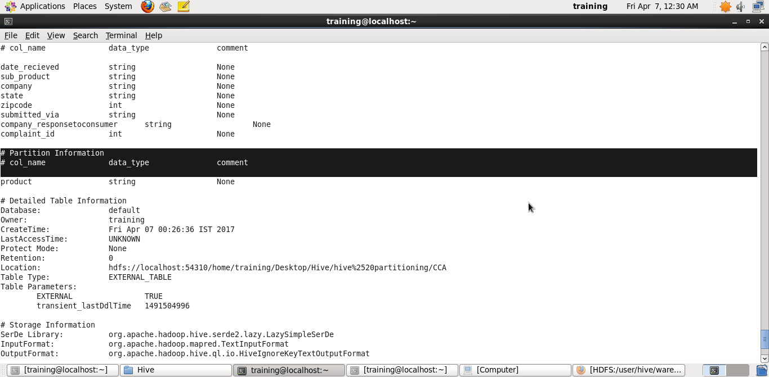

**show create table cca_partion;**

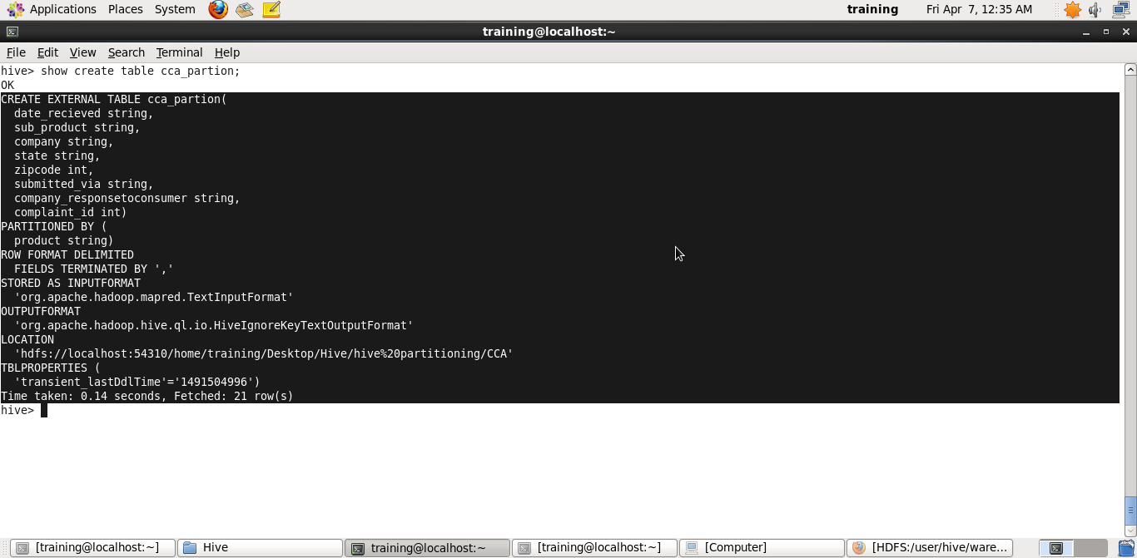

INSERTING DATA INTO PARTIONED TABLE – **STATIC INSERT**

hive (default)> INSERT OVERWRITE TABLE cca_static_partion PARTITION(Product='Consumer loan') SELECT date_recieved,Sub_Product,COMPANY,STATE,ZIPCODE,Submitted_via,Company_responsetoconsumer,Complaint_ID FROM CCA WHERE Product='Consumer loan';

Drawbacks of static insert:

If we go for the above approach , if we have 50 partitions we need to do the insert statement 50 times. That is a tedious task.

**INSERTING DATA INTO PARTIONED TABLE – Dynamic INSERT**

First create an external table for it :

CREATE EXTERNAL TABLE CCA_DYNAMIC_PARTITION2 (date_recieved STRING,Sub_Product STRING,Company STRING,State STRING ,Zipcode INT, Submitted_via STRING, Company_responsetoconsumer STRING,Complaint_ID INT) PARTITIONED BY (Product string)

> ROW FORMAT DELIMITED FIELDS TERMINATED BY ','

> LOCATION '/user/hive/warehouse/CCA/';

**In order to achieve the same we need to set 4 things,**

1. **set hive.exec.dynamic.partition=true;**

This enable dynamic partitions, by default it is false.

1. **set hive.exec.dynamic.partition.mode=nonstrict;**

* By default strict – Because it may leads to so many number of partitions
* NonStrict- We are explicitly specifying no of partitions.
* If strict we cannot perform queries like – select * from --------------(here we have to use where clause). i.e It restricts queries of partitioned tables without a **WHERE** clause.
* But for nonstrict mode we can perform.
* It restricts **ORDER BY** operation without a **LIMIT** clause ( since it uses a single reducer which can choke your processing if not handled properly

1. **set hive.exec.max.dynamic.partitions.pernode=3;**

The default value is 100, we have to modify the

same according to the possible no of partitions

1. **set hive.exec.max.created.files=150000;**

The default values is 100000 but for larger tables. It can exceed the default, so we may have to update the same.

If the table has only dynamic partition columns

Change dynamic partition mode to non-strict:

By default strict: To prevent accidental creation of partition.

Insert

INSERT OVERWRITE TABLE cca_dynamic_partition2 PARTITION(Product) SELECT date_recieved,Sub_Product,COMPANY,STATE,ZIPCODE,Submitted_via,Company_responsetoconsumer,Complaint_ID,Product FROM CCA;

Here Product ( i.e partitioning column) should be in last item.

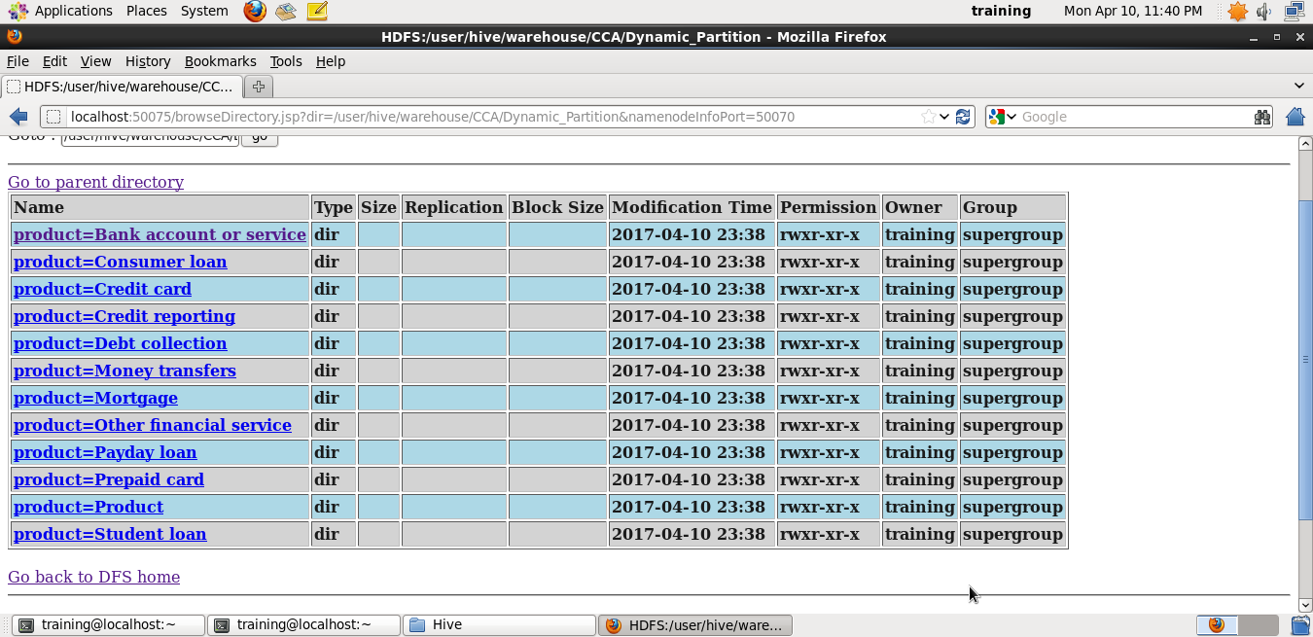

**Partition by Company:**

CREATE EXTERNAL TABLE CCA_DYNAMIC_PARTITION_Company2 (date_recieved STRING, Product string, Sub_Product STRING, State STRING ,Zipcode INT, Submitted_via STRING, Company_responsetoconsumer STRING,Complaint_ID INT) PARTITIONED BY (Company string)

> ROW FORMAT DELIMITED FIELDS TERMINATED BY ','

> LOCATION '/user/hive/warehouse/CCA/CCA_DYNAMIC_PARTITION_Company';

INSERT OVERWRITE TABLE CCA_DYNAMIC_PARTITION_Company2 PARTITION(Company) SELECT date_recieved,Product,Sub_Product,STATE,ZIPCODE,Submitted_via,Company_responsetoconsumer,Complaint_ID,Company FROM CCA;

Partition by Multiple column:

First Partition – Product.

Under product: Partition by sub_product.

CREATE EXTERNAL TABLE CCA_DYNAMIC_PARTITION_Multiple (date_recieved STRING,Company STRING,State STRING ,Zipcode INT, Submitted_via STRING, Company_responsetoconsumer STRING,Complaint_ID INT) PARTITIONED BY (Product string, Sub_Product STRING)

> ROW FORMAT DELIMITED FIELDS TERMINATED BY ','

> LOCATION '/user/hive/warehouse/CCA/CCA_DYNAMIC_PARTITION_Multiple';

INSERT OVERWRITE TABLE CCA_DYNAMIC_PARTITION_Multiple PARTITION(Product, Sub_Product) SELECT date_recieved,COMPANY,STATE,ZIPCODE,Submitted_via,Company_responsetoconsumer,Complaint_ID,Product, Sub_Product FROM CCA;

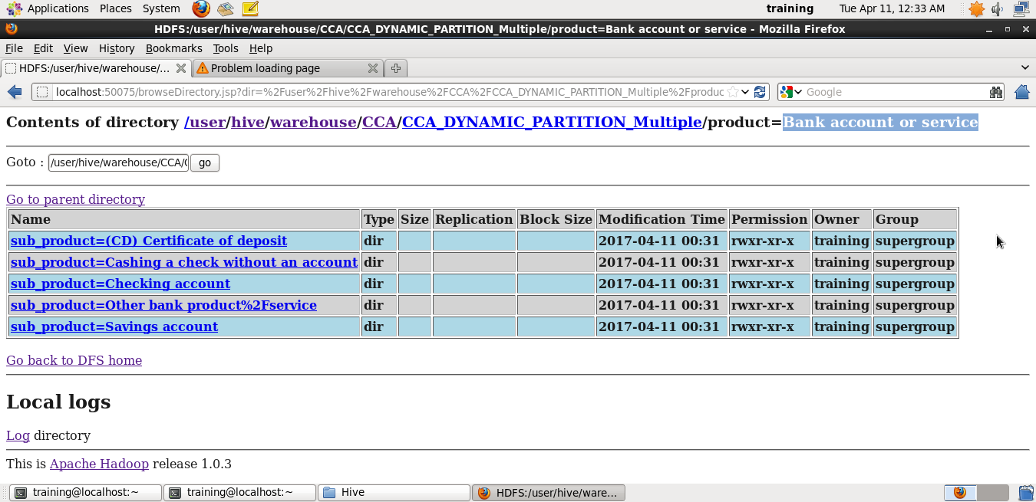

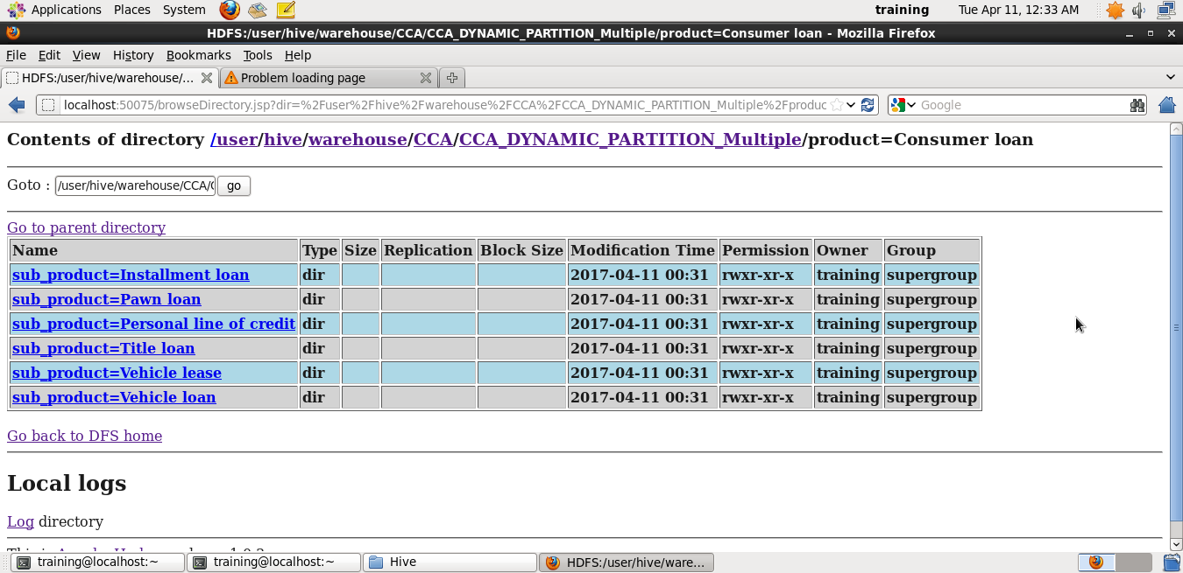

To show how many partitions that a table had?

Show partitions cca_dynamic_partition_multiple;

